A multilingual glossary of fashion
Textiles and textures
WORD | DEFINITION | IMAGE | CROATIAN | SLOVENIAN | GERMAN | FRENCH
canvas | strong, rough cloth used for making tents, sails and strong clothes | 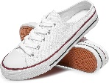 | platno
cashmere | fine, soft wool made from the long hair of a type of goat, used especially for making expensive clothes | 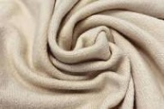 | kašmir |  | Kaschmir
chenille | a type of thick, soft thread; cloth made from this | 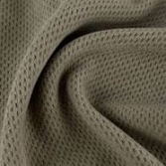 | šanil |  | Chenille
chiffon | a type of fine cloth that you can see through, made from silk or nylon | 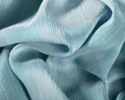 | šifon |  | Chiffon
corduroy | a type of strong soft cotton cloth with a pattern of raised straight lines on it | 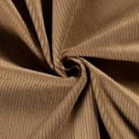 | samt |  | Cord
cotton | cloth made from the cotton plant | 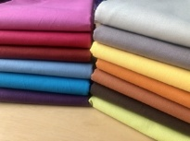 | pamuk |  | Baumwolle
damask | a type of thick cloth, usually made from silk or linen with a pattern that can be seen on both sides | 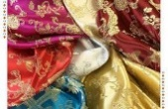 | damast |  | Damast
denim | a type of strong cotton cloth that is usually blue and is used for making clothes, especially jeans | 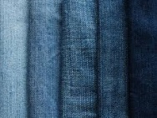 | traper |  | Denim
elastane | an artificial material that stretches easily and is used for making underwear, stockings… | 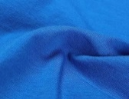 | elastan |  | Elasthan
fluffy | of, like, or covered with fluff that is soft fibres from fabrics such as wool or cotton which accumulate in small light clumps | 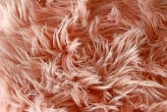 | pahuljast, čupav
fur | the hair-covered skin of animals removed from their bodies | 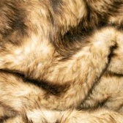 | krzno
furry | covered with fur, or feeling or looking like fur | 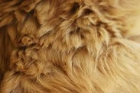 | krznen |  |  | ss
fuzzy | covered with short soft fine hair or fur | 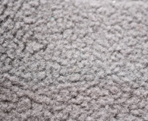 | pahuljast
lace | a very thin material made from threads of cotton or silk that are made into a pattern with holes | 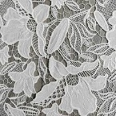 | čipka |  | Spitze
lacy | very made of, resembling, or trimmed with lace | 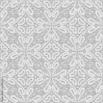 | čipkast
latex | a thick white liquid that is produced by some plants and trees, especially rubber trees used to make clothes | 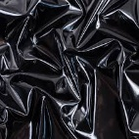 | lateks |  | Latex
leather | material made by removing the hair or fur from animal skins | 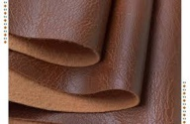 | koža |  | Leder
linen | a type of cloth made from flax, used to make high-quality clothes or sheets | 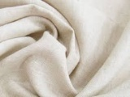 | lan |  | Leinen
nylon | a very strong artificial material, used for making clothes | 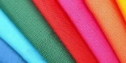 | najlon |  | Nylon
polyester | a strong material made of fibres which are produced by chemical processes, often mixed with other materials and used especially for making clothes |  | poliester |  | Polyester
rough | having a surface that is not even or regular | 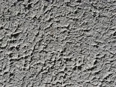 | grub, hrapav |  | Rauch
satin | a type of cloth that is smooth and shiny, sometimes made of silk |  | saten
shiny | (of a smooth surface) reflecting light, typically because very clean or polished |  | sjajan
silk | fine soft thread produced by silkworms | 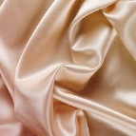 | svila |  | Seide
smooth | completely flat and even, without any rough areas or holes |  | gladak |  | Glatt
sparkly | shining with glittering flashes of light | 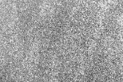 | svjetlucav
terry | a type of soft cotton cloth that has a surface covered with raised loops of thread, used especially for making towels | 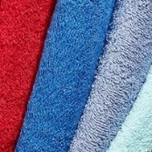 | frotir |  | Frattee
velvet | a cloth usually made from silk or cotton with a thick, soft surface | 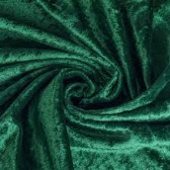 | baršun
wool | a cloth made from animal’s wool, used for making clothes | 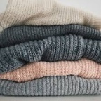 | vuna |  | Wolle
woolly | made of wool | 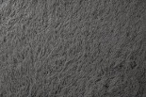 | vuneni

