A multilingual glossary of fashion
Making clothes
WORD | DEFINITION | IMAGE | CROATIAN | SLOVENIAN | GERMAN | FRENCH
applique | a decorative design made by cutting out and stitching a different piece of fabric or material onto a larger piece to create a pattern or picture | 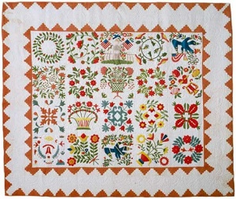 | aplikacija, emblem |  | Applikationen?
bead | a small, round, decorative object made from various materials, pierced with a hole and sewn onto clothing or jewellery | 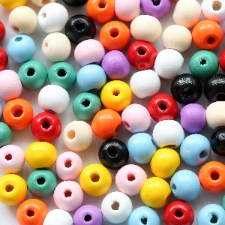 | perla, perlica |  | die Perle
crochet | creating textiles by using a crochet hook | 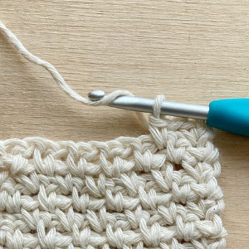 | kukičanje, kačkanje, heklanje |  | häkeln
crochet hook | a needle with a hook at one end used to make clothes and other things from wool or cotton thread | 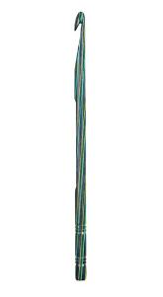 | igla za heklanje, kačkalica |  | Häkelnadel
darning ball | an egg-shaped tool used as a support during darning | 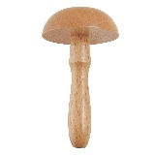 | gljiva za krpanje |  | Stopfball
dressmaker | a person who creates custom-made clothing, specializing in the design and construction of dresses | 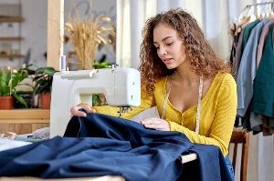 | krojač specijaliziran za krojenje i izradu haljina |  | (die) Schneiderin  (der) Schneider
dressmaker's model | a three-dimensional model of the human body used by dressmakers and designers for fitting and designing clothing | 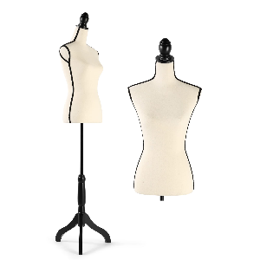 | trodimenzionalni model u obliku ljudskog kojeg koriste dizajneri I krojači za prilagođavanje odjeće |  | Schneidermodell ?
dummy  mannequin | a replica figure used for displaying or fitting clothes | 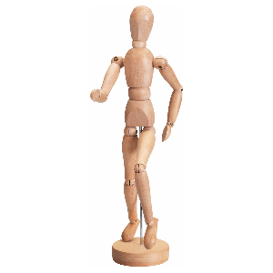 | lutka u izlogu, krojačka lutka |  | Schaufensterpuppe ?
embroidery  needlework | the activity of decorating a piece of cloth with stitches sewn onto it | 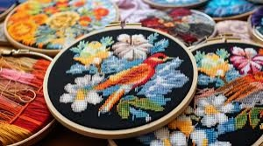 | vez, vezenje |  | Stickerei-Handarbeit
fringe | a decorative border made of hanging threads, cords, or strips, often used to embellish clothing or accessories | 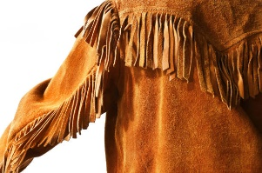 | rese, resice |  | die Franse
garment worker | a person who works in the clothing manufacturing industry | 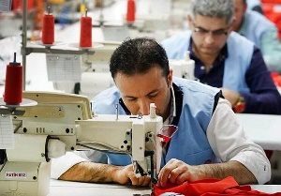 | radnik u industriji odjeće, tekstilni radnik |  | Textilarbeiter
hemline | the length of a skirt or a dress, or a lower edge of a skirt or a dress | 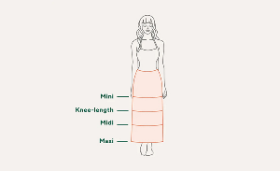 | duljina suknje ili haljine; porub |  | Saum
knitting | creating clothing, fabric, etc., typically from wool or thread, using a machine or a pair of long and thin needles | 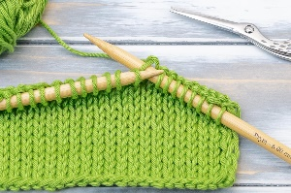 | pletenje |  | stricken
knitting needle | a long, thin, pointed tool used in knitting to hold stitches and manipulate yarn | 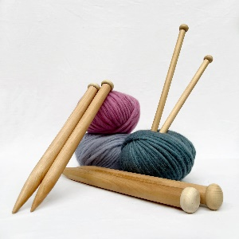 | igla za pletenje |  | Stricknadel
knitting yarn | yarn used for hand-knitting projects, typically made of various fibres and colours, and used with knitting needles or other tools to create knitted fabric | 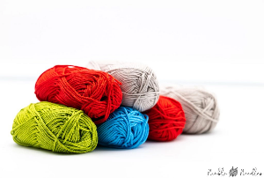 | vuna za pletenje |  | Strickgarn
pin | a slender, elongated object typically made of metal, that has a sharp point at one end and a flat or rounded head at the other | 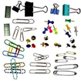 | igla, pribadača |  | die Anstecknadel
pincushion | a small pad used to hold and store sewing pins and needles during sewing | 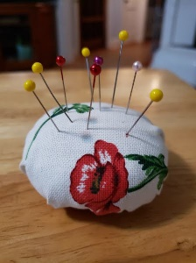 | jastučić za čuvanje igli |  | ?
ribbon | a long, narrow strip of fabric, used for tying something or for decoration | 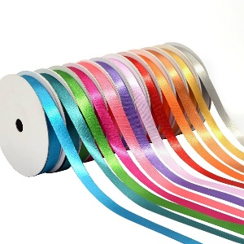 | vrpca |  | die Schleife ?
running stitch | a simple, straight stitch used for basic sewing | 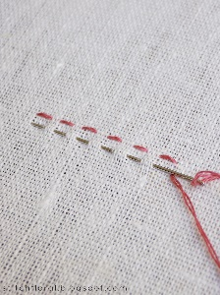 | osnovni bod |  | der Vorstich
safety pin | a type of pin that has a simple spring-loaded mechanism and is used to fasten or secure items temporarily | 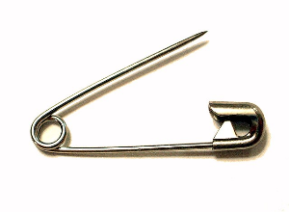 | sigurnosna igla, ziherica |  | Sicherheitsnadel
tailor scissors | specialized scissors designed for cutting fabric, with long blades and sharp points for precise and clean cuts, often used by tailors and dressmakers | 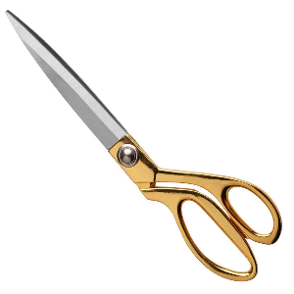 | krojačke škare |  | Schneiderschere
seam | a line of stitching that joins two or more pieces of fabric together | 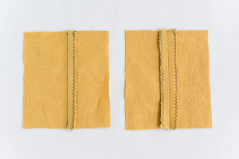 | šav |  | Naht
seamstress | a woman whose job is sewing and making clothes |  | švelja |  | Näherin
sequin | A small, shiny metal or plastic disk sewn on clothes for decoration | 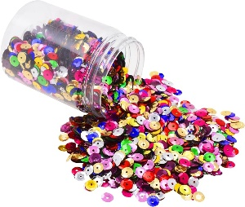 | šljokica |  | Paillette
sewing | creating clothing by joining pieces of fabric together using a needle and thread | 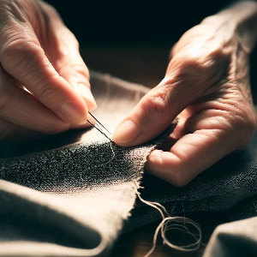 | šivanje |  | Nähen
sewing chalk | a chalk-like tool used in sewing to mark fabric for cutting, sewing, or other adjustments | 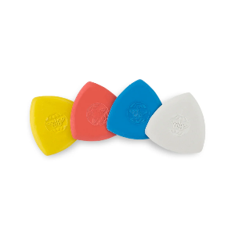 | kreda za crtanje po tkanini |  | Nähkreide
sewing machine | a machine used to sew fabric and other materials together with thread | 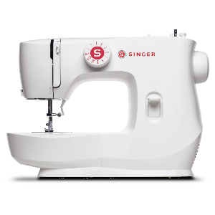 | šivača mašina |  | Nähmaschine
sewing needle | a slender, pointed tool used for sewing fabrics and other materials | 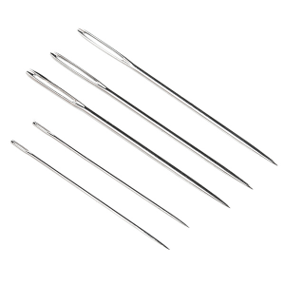 | šivača igla |  | Nähnadel
sewing pattern | the template from which the parts of a garment are traced onto woven or knitted fabrics before being cut out | 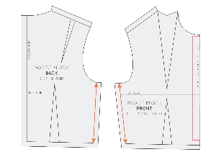 | kroj |  | Schnittmuster
stitch | a piece of thread sewn in cloth, or the single movement of a needle and thread into and out of the cloth that produces this | 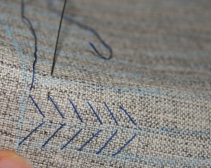 | bod, šav |  | der Stich
straight pin | a thin, pointed metal or plastic rod with a head on one end, used in sewing to hold fabric together temporarily | 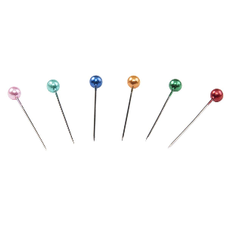 | pribadača, špenadla |  | gerader Stift
tailor | a person whose job is making clothes, especially for men | 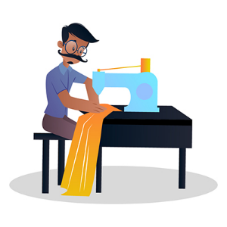 | krojač muške odjeće |  | Schneider
tape measure | a measuring tape is a flexible tool used for measuring length; it is made up of materials like fiberglass, cloth, plastic, metal ribbon or strip | 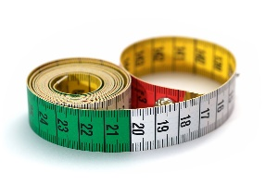 | mjerna vrpca, metar |  | Bandmaß
thimble | a small cover worn to protect the finger that pushes the needle when sewing | 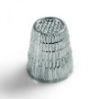 | naprstak |  | Fingerhut
thread | a thin strand of material, such as cotton, nylon, or silk, used for sewing or weaving | 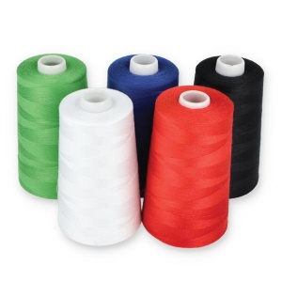 | konac |  | das Garn
trim | to make something, like clothing, look better by adding decorative elements | 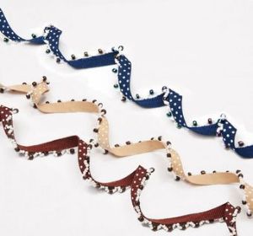 | dotjerati ukrasima, npr. vrpcama |  | trimmen
velcro | (trademark) a material with two different surfaces one of which sticks to the other by some small hooks, when pressed, used as a fastener | 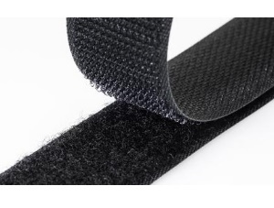 | čičak traka |  | Klettverschluss

