A multilingual glossary of fashion
Headgear
WORD | DEFINITION | IMAGE | CROATIAN | SLOVENIAN | GERMAN | FRENCH
Akubra | an Australian hat made of rabbit fur felt with wide brims that are worn in rural Australia | 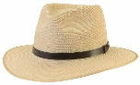 | australski šešir Akubra |  | der australische Hut Akubra
Ba tam | a traditional Vietnamese flat palm hat | 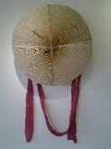 | vijetnamski šešir Ba tam |  | der vietnamesische Hut Batam
Balmoral hat | a traditional Scottish cap that can be worn as part of formal or informal Highland dress | 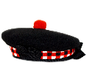 | škotska kapa Balmoral |  | die Schulmütze Balmoral
baseball cap | a soft hat with a rounded crown and a stiff bill projecting in front |  | kapa za bejzbol, šilterica |  | die Baseballkappe
batting helmet | a helmet worn by batters in the game of baseball or softball | 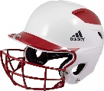 | kaciga za bejzbol |  | der Baseballhelm
beanie | a head-hugging brimless cap | 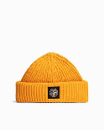 | kapica |  | die Mütze
beret | a soft, round, flat-crowned cap made of hand-knitted wool | 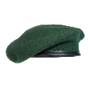 | beretka, francuska kapa |  | das Barett
boater | a semi-formal summer hat for men, popularised in the late 19th, early 20th century | 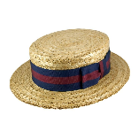 | čvrsti, slamnati šešir |  | der feste Strohhut
bobble hat | a hat made from wool with a small, round wool ball on top; traditional or old-fashioned British working-class football regalia | 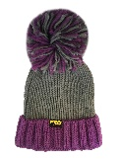 | vunena kapa s coflekom |  | die Wollmütze mit Bommel
bowler hat | a black man’s hat with a round, hard top | 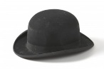 | polucilindar |  | der Halbzylinder
cricket hat | a type of soft cap often made from felt | 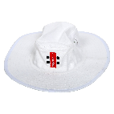 | kapa za kriket |  | die Cricketkappe
crown | a traditional form of head adornment, or hat, worn by monarchs as a symbol of their power and dignity | 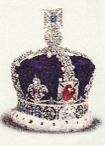 | kruna |  | die Krone
diving mask | an item of diving equipment that allows underwater divers to see clearly underwater | 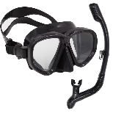 | ronilačka maska |  | die Tauchermaske
fedora | a hat with a soft brim and indented crown | 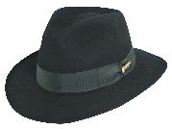 | fedora šešir |  | der Fedora-Hut
garrison cap, side cap | a military cap that can be folded flat when not worn | 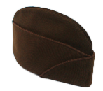 | bočna kapa; vojnička kapa |  | die Feldmütze
homburg | a semi-formal man’s hat made of fur felt, characterized by a single gutter crown | 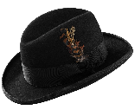 | homburški šešir |  | der Homburg-Hut
hood | part of a piece of clothing that can be pulled up to cover the top and back of the head | 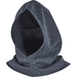 | kapuljača |  | die Kapuze
kippa | a brimless cap usually made or cloth, traditionally worn by Jewish males | 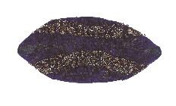 | kipa; jarmulka |  | die Jarmulka
leather flight helmet | a leather cap with large earflaps, a chin strap and often a short bill | 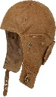 | kožna pilotska kaciga |  | der Lederpilotenhelm
party hat | a conical hat made of a piece of thin paperboard |  | šešir za zabavu |  | der Partyhut
Phrygian cap | a soft, conical hat with the top curled forward, a symbol of liberty, worn by Smurfs and Olympic mascot 2024 | 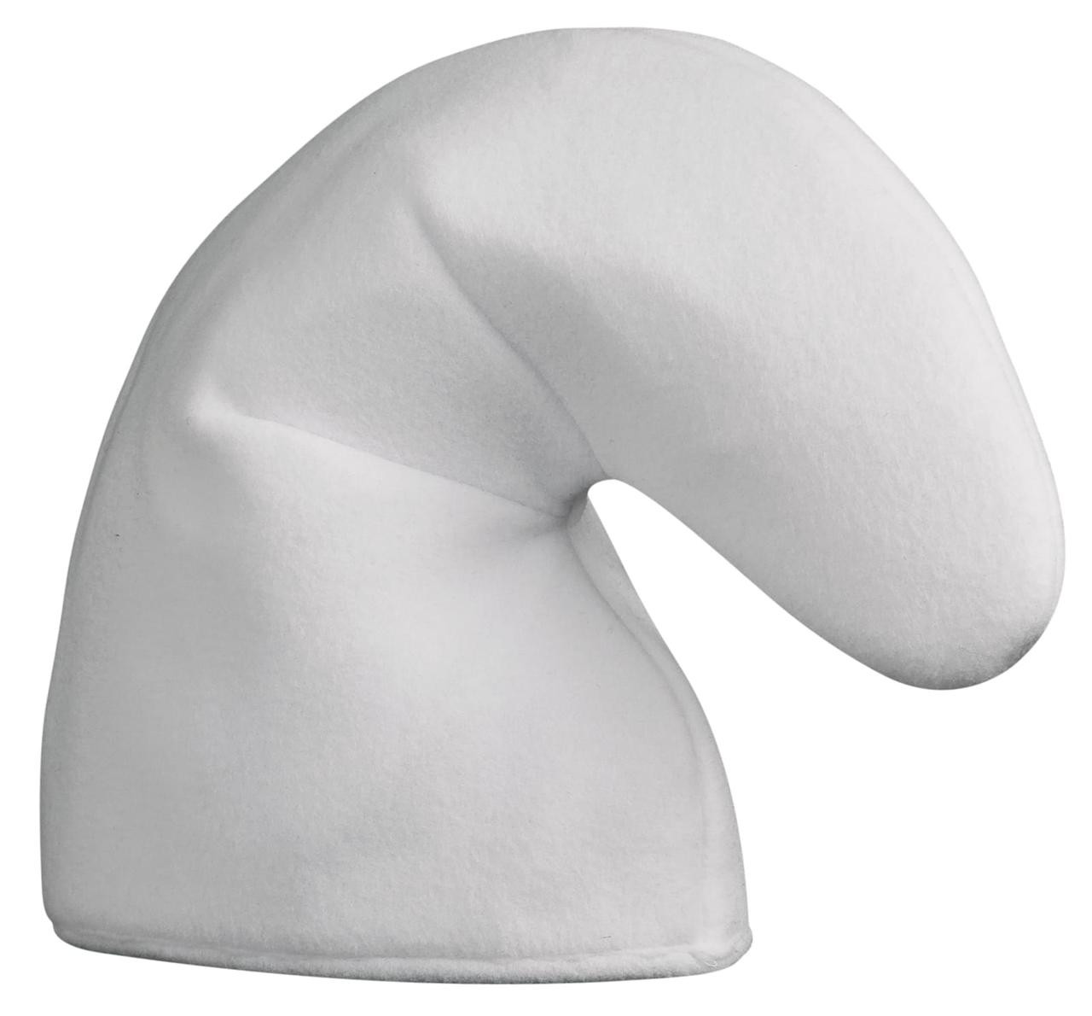 | frigijska kapa |  | die Phrygische Mütze
sailor hat | a brim straw hat | 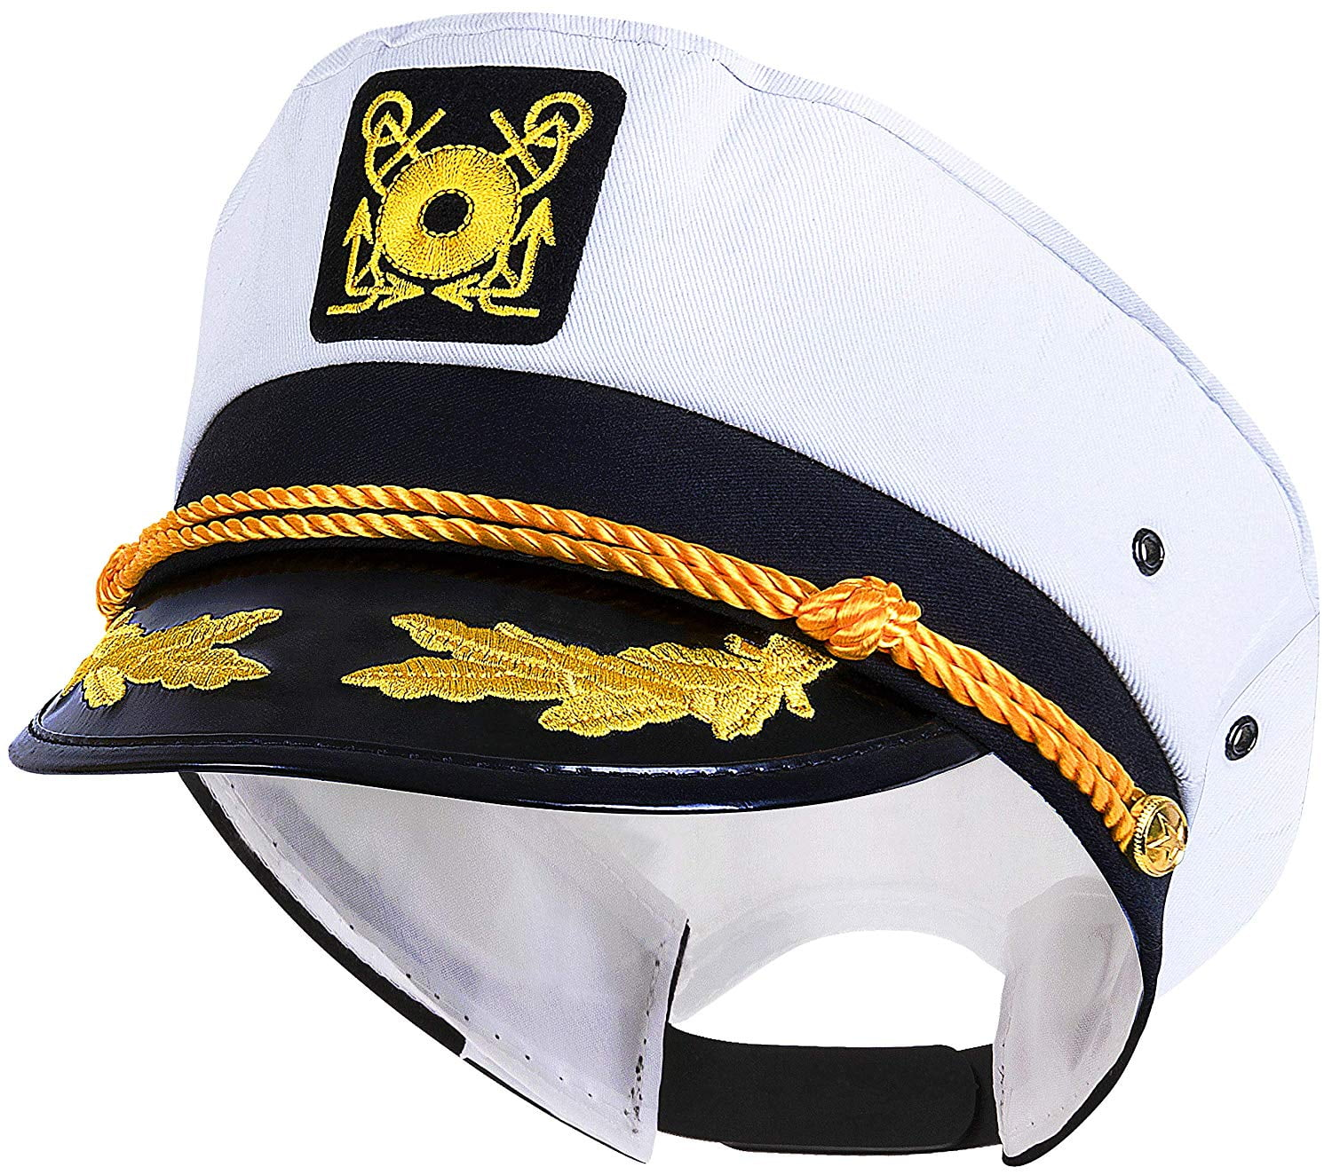 | mornarski šešir |  | der Matrosenhut
skullcap | usually refers to various types of headgear | 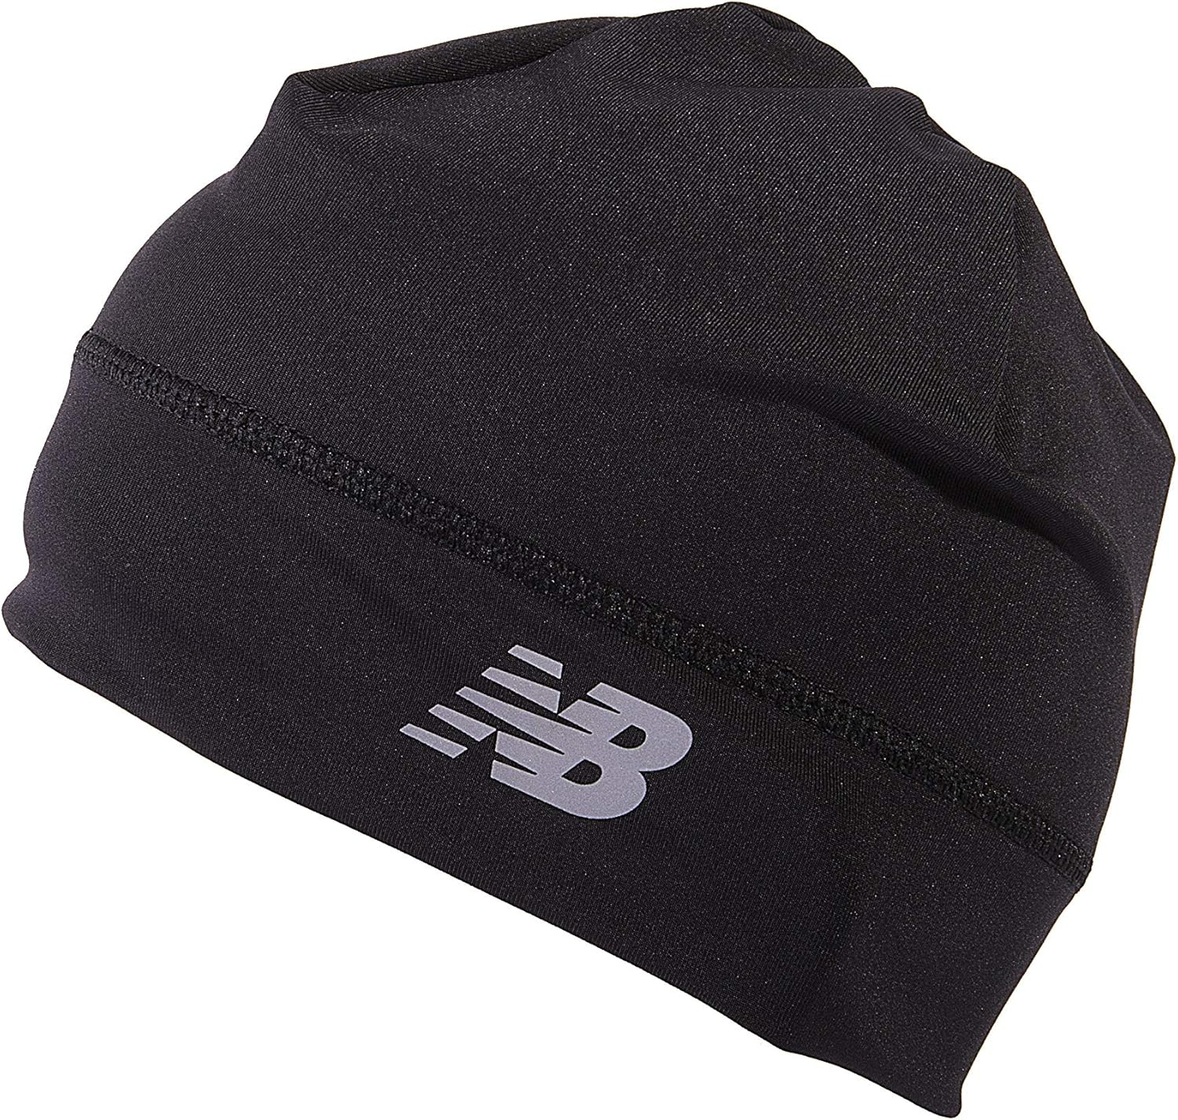 | okrugla kapica |  | das Rundkäppchen
sombrero | a type of wide-brimmed Mexican men’s hat | 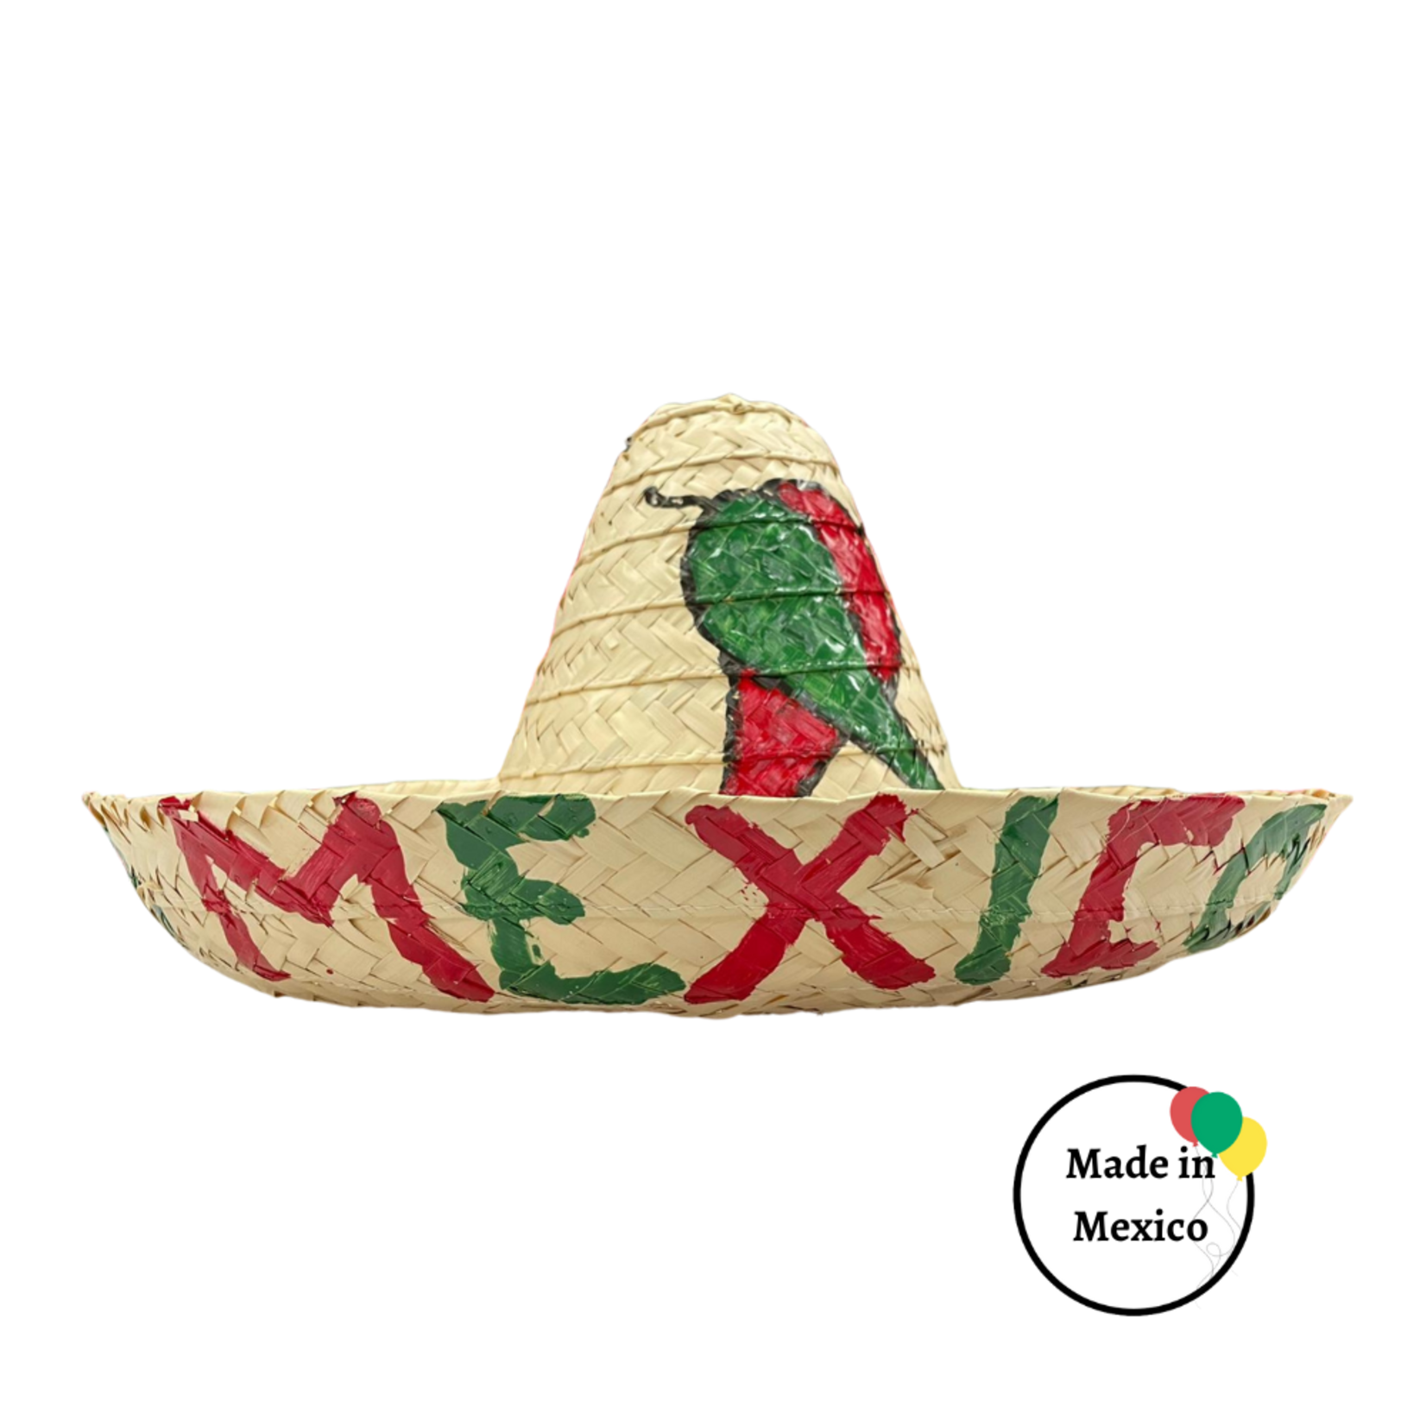 | meksički šešir sombrero |  | der mexikanische Sombrero
sports visor | a type of crownless hat consisting of a visor with a strap encircling the head | 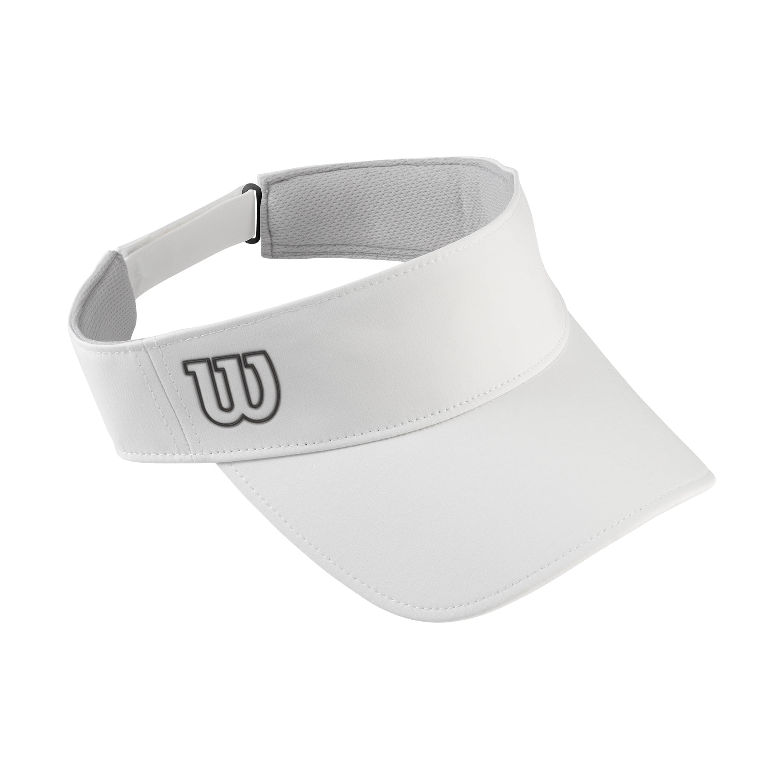 | sportski vizir |  | der Sportvisier
tiara | a jewelled head ornament | 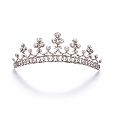 | tijara |  | die Tiara
top hat | a tall, black hat worn by men on formal occasions | 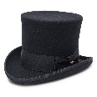 | cilindar |  | der Zylinder
turban | a type of headwear based on cloth winding | 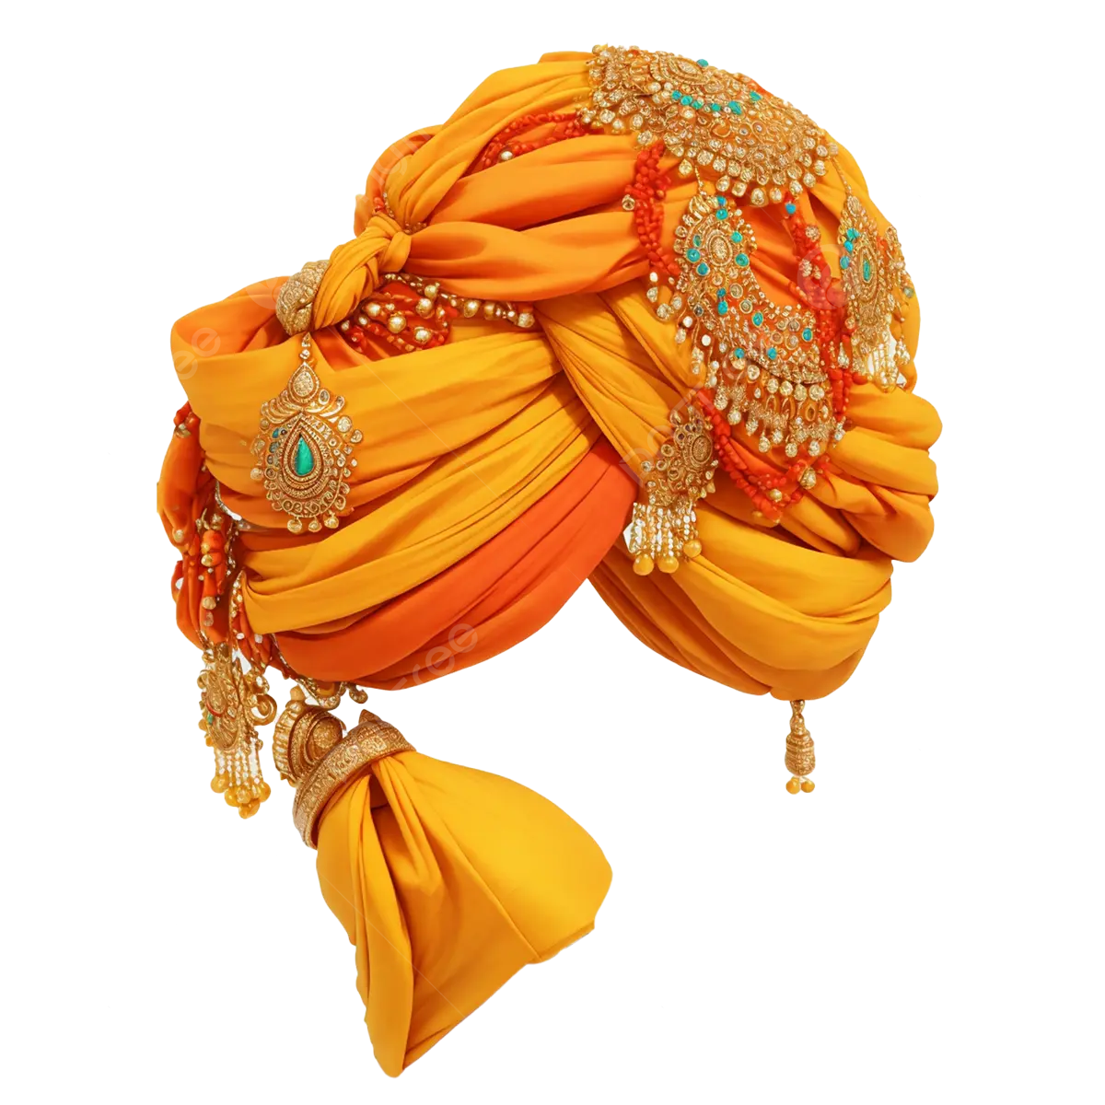 | turban |  | der Turban
umbrella hat | an umbrella canopy attached to a headband that functions as a protection against the drizzle rain or sun | 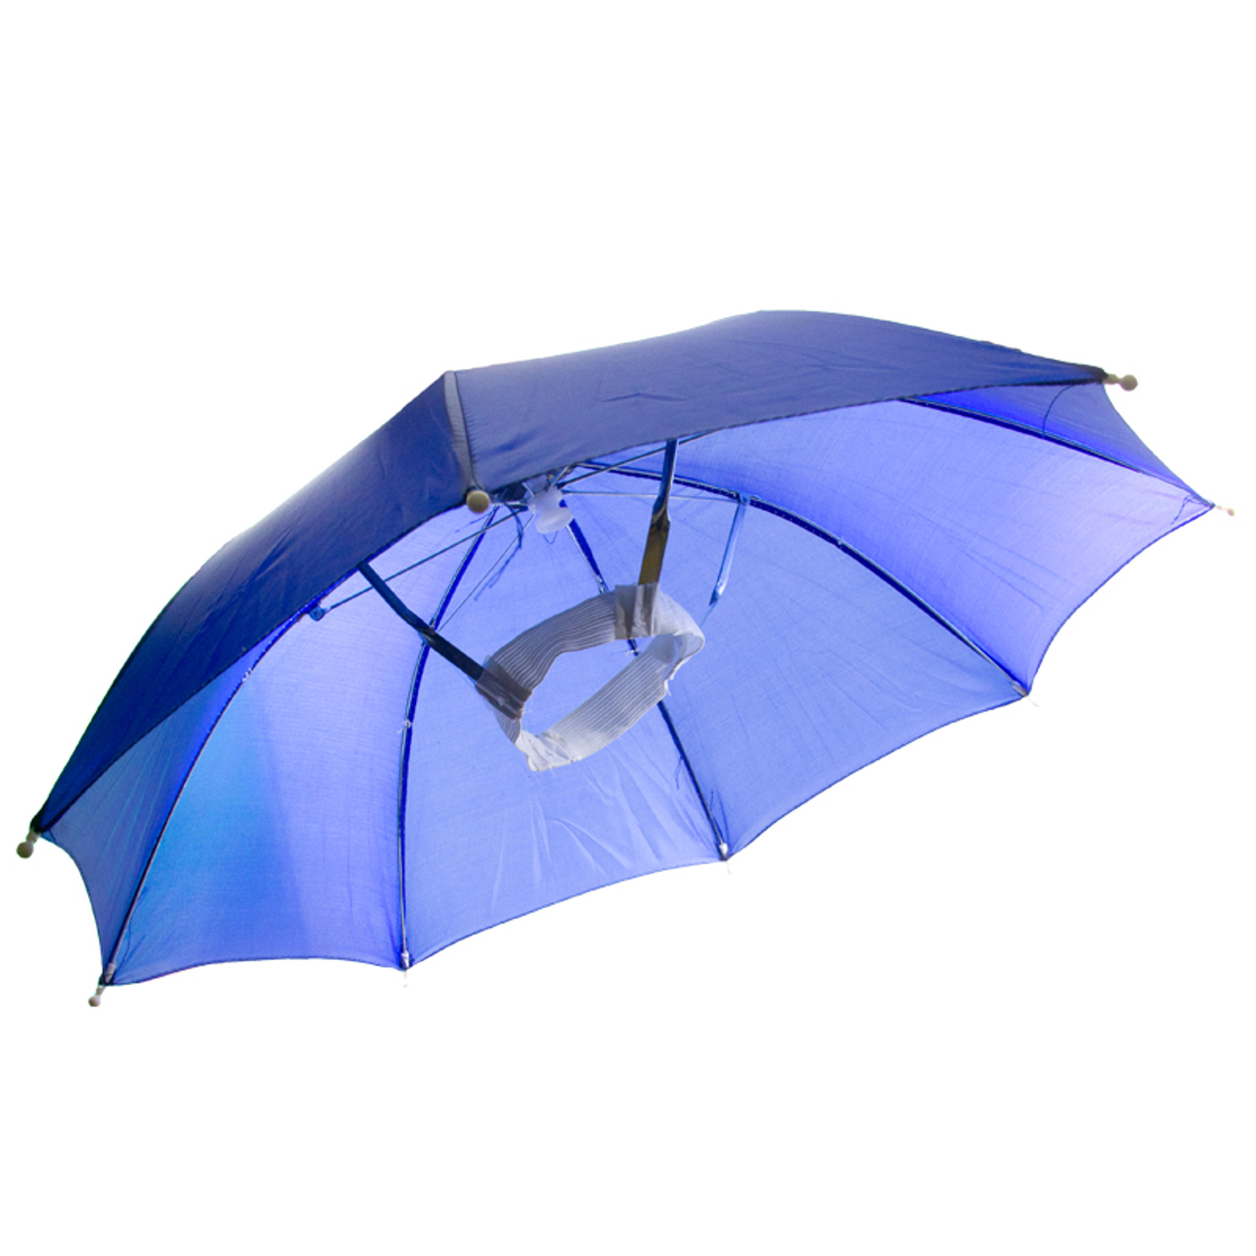 | kapa s kišobranom |  | die Regenschirmmütze
ushanka | a Russian fur hat with ear-covering flaps that can be tied up on the crown of the hat | 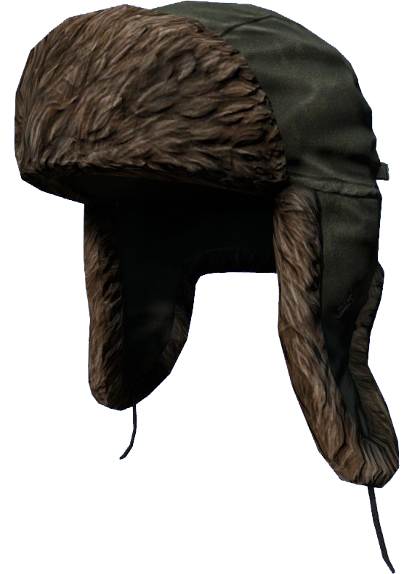 | zimska lovačka kapa s preklopom za uši |  | die Winter-Jägermütze mit Ohrenklappen
wedding veil | a piece of thin material worn by women to cover the face of head at the wedding | 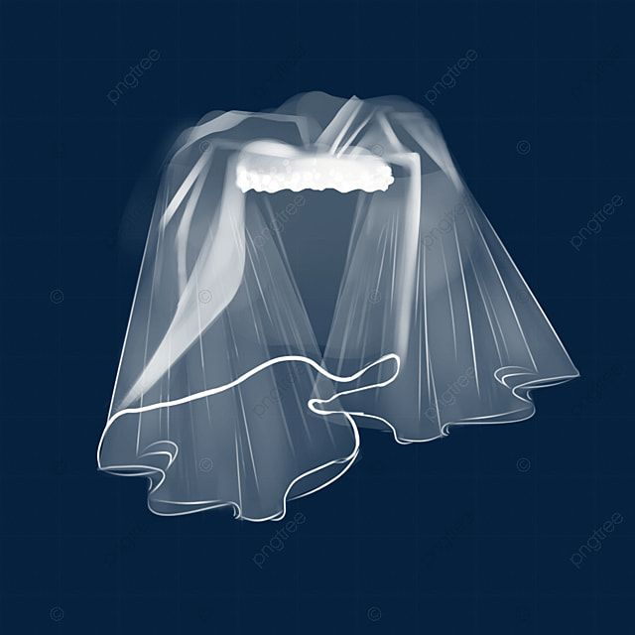 | vjenčani veo, šlajer |  | der Hochzeits Schleier
wig | head covering made from human or animal hair, or a synthetic imitation thereof | 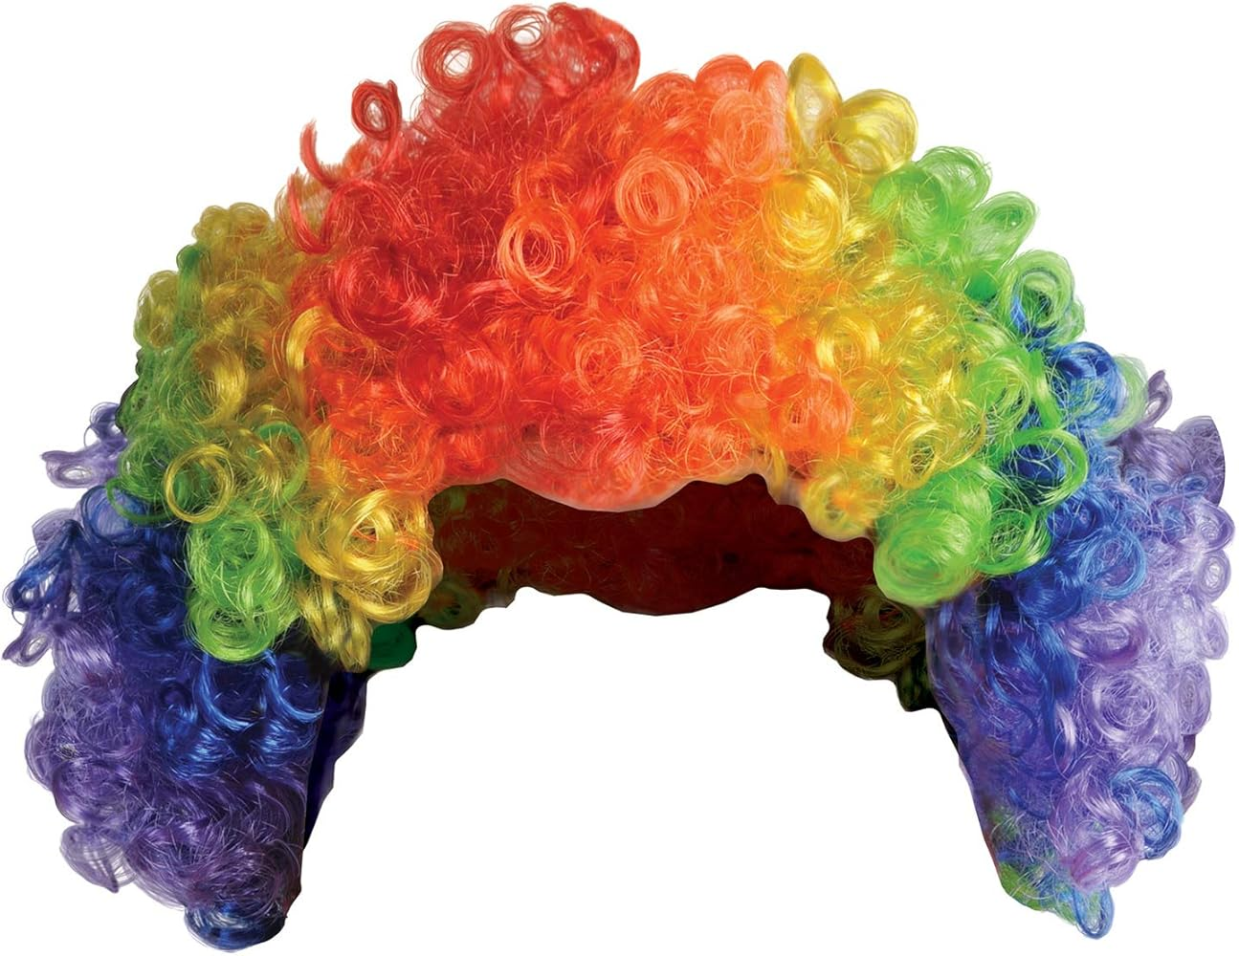 | perika |  | die Perücke

