A multilingual glossary of fashion
Footwear
WORD | DEFINITION | IMAGE | CROATIAN | SLOVENIAN | GERMAN | FRENCH
ballet flat | women’s shoes for everyday which are similar to or inspired by a women’s ballet shoes | 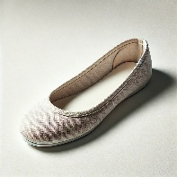 | balerinka |  | Der Spitzschuh
boot | a sturdy idem of footwear covering the foot and ankle | 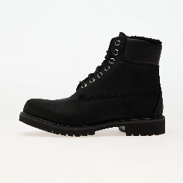 | čizma |  | Der Stiefel
Chelsea boot | a type of short boot that covers the foot and ankle with a thick sole, small heel and an elasticised part at the side | 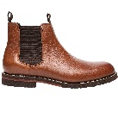 | niska čizma |  | Der Chelsea- Stiefel
clog | a type of shoe made of wood, or the top part made of leather and the bottom part of wood | 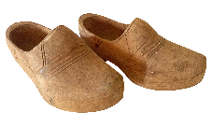 | klompa |  | Der Holzschuh
cowboy boot | a type of a leather boot with a high heel and a pointed toe | 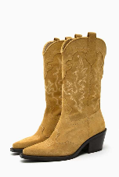 | kaubojska čizma |  | Der Cowboystiefel
espadrille | a light shoe made of strong cloth with a sole made of rope | 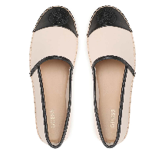 | espadrila |  | Die Espadrille
flip flop | a type of shoe, often made of rubber with a V-shaped strap that goes between the big toe and the toe next to it | 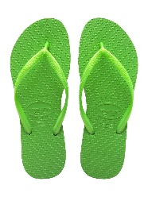 | japanka |  | Die Flipflops
football boot | a leather shoe with studs, worn for playing football | 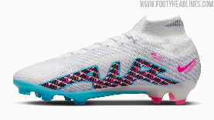 | kopačka |  | Der Fußballschuh
gladiator sandal | an open-toed T-bar sandal with multiple straps running across the foot | 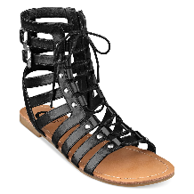 | gladijatorska sandala |  | Die Gladiator-Sandale
high heels | shoes that have very high heels | 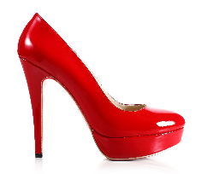 | cipele s visokom petom, štikle |  | Die Pumps
hiking boots | footwear specifically designed for protecting the feet and ankles during outdoor walking activities such as hiking | 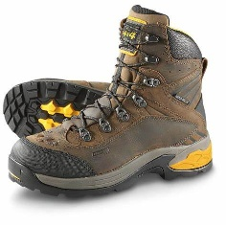 | gojzerice |  | Der Wanderschuh
kitten heels | a pair of shoes with a thin curved heel that is not very high, usually worn by women | 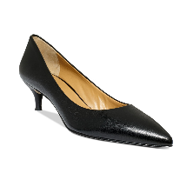 | ženske cipele s niskom potpeticom |  | Der Kätzchenhügel
loafer | a type of leather shoe without a fastening | 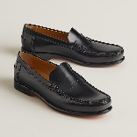 | mokasina
low heels | shoes with low heel | 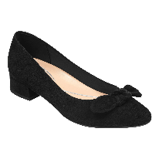 | cipele s niskom petom
oxfords | leather shoes that fasten with laces | 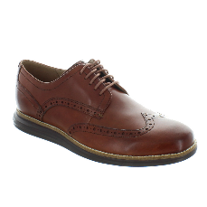 | oksfordice
peep-toe | a shoe or sandal in which the big toe is not covered | 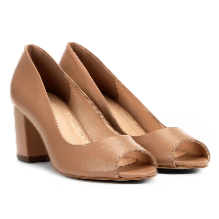 | cipela s otvorenim prstom
running shoe | a type of light, comfortable shoe that is suitable for running | 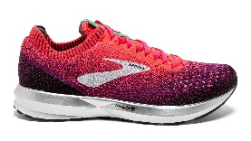 | tenisica za trčanje |  | Die Laufschuhe
sandal | opened type of shoes | 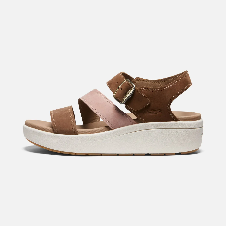 | sandala |  | Die Sandale
shoe | a covering for the foot | 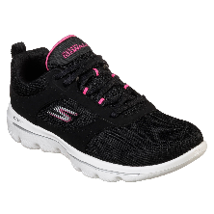 | cipela |  | Der Schuh
slipper | a loose, soft shoe that you wear in the house | 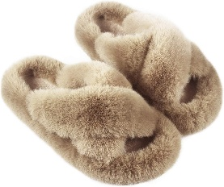 | papuča |  | Die Hausschuhe
snow boot | a boot reaching to the ankle or above for wear in snow | 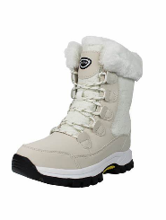 | čizma za snijeg |  | Der Schneestiefel
stiletto heel shoe | a shoe with a long, thin, high heel usually worn by women | 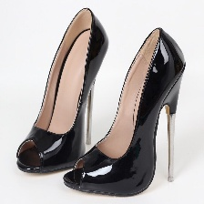 | ženska cipela s izrazito tankom i visokom potpeticom
suede shoe | a shoe made of leather whose surface has been made slightly rough so that it is soft but not shiny | 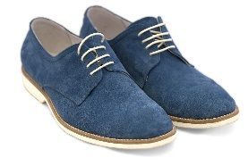 | antilop cipela
trainer (BrE)  sneaker (AmE) | a shoe that you wear for sports or as informal clothing | 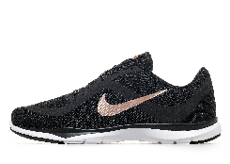 | tenisica |  | Die Turnschuhe
wellington boot / wellie (BrE)  rubber boot (AmE) | a boot that you wear to stop your feet getting wet | 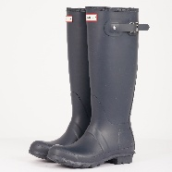 | gumena čizma |  | Der Gummistiefel

